Contents

**No table of contents entries found.**

1. To docker **–version**
2. **docker . -t eazybytes/accounts**  
   To build an image for your app.  
   Timeline

   Description automatically generated
3. **To see/list all the images on our system.  
   Command 🡺 docker images**Graphical user interface

   Description automatically generated with low confidence
4. **To inspect an image  
   docker image inspect <image-id>**Graphical user interface, text

   Description automatically generated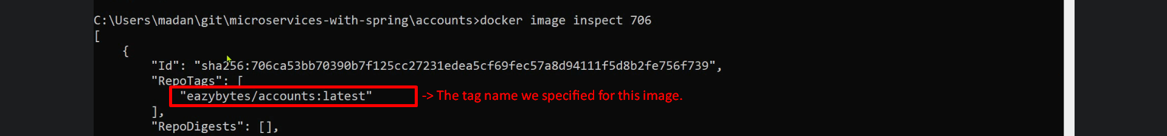Text

   Description automatically generated
5. **To run and expose port**:  
   docker run -p <external-port>:<internal-container-port> <image-id>  
   Text

   Description automatically generated
   1. **Options**
      1. -t:
         1. -t <tagName>
      2. -d:
         1. Just -d is enough.
6. To Print Logs
   1. **Command**:
      1. Docker logs <container-id>
         1. Will print logs up to now and then command prompt will return.
   2. **Options**:
      1. -f: The command prompt will not return and the command will follow all the logs for the container till container is running.
7. To stop a running container:
   1. **Command**:
      1. Docker stop <container-id>
8. To list all the running containers:
   1. **Command**:
      1. Docker pw
         1. To list running containers.
   2. **Options**
      1. -a or –all: To print even the stop containers
9. To restart a stopped container
   1. **Command**:
      1. Docker start <container-id>
10. To pause a container:
    1. Command:
       1. Docker pause <container-id>
11. To unpause a container:
    1. Command:
       1. Docker unpause <container-id>
12. To kill a running container:
    1. **Command**:
       1. Docker kill <container-id>
          1. This command can be compared with “Docker stop”.
          2. Docker Stop command will stop a running container gracefully for 10secs but this does not.
13. To print statistics of all containers:
    1. **Command**:
       1. Docker stats
14. To remove stopped containers:
    1. **Command**:
       1. Docker rm <container-id> <container-id> … <container-id>
15. To create image with Spring Boot Maven plugin
    1. Graphical user interface, text, application, email

       Description automatically generated  
       **Above**: <name>eazybytes/${project.artifactId} where eazybytes is my Docker ID.
    2. **Command**:
       1. Mvn spring-boot:build-image
16. About Docker Compose Command:
    1. **Commands**:  
       Graphical user interface, text, application

       Description automatically generated
       1. Text

          Description automatically generated  
          
17. To push the latest image onto Docker Hub
    1. Command:
       1. Docker push docker.io/<repo>/accounts